Project Report

1 . INTRODUCTION

Our project is a CRM Application which helps the applicant to track the No.of jobs he applied and helps him to find the job posted by the various recruiters, find the best attributes to be involved to run the process in a smooth way and easily to track.

2 . Problem Definition & Design Thinking :-

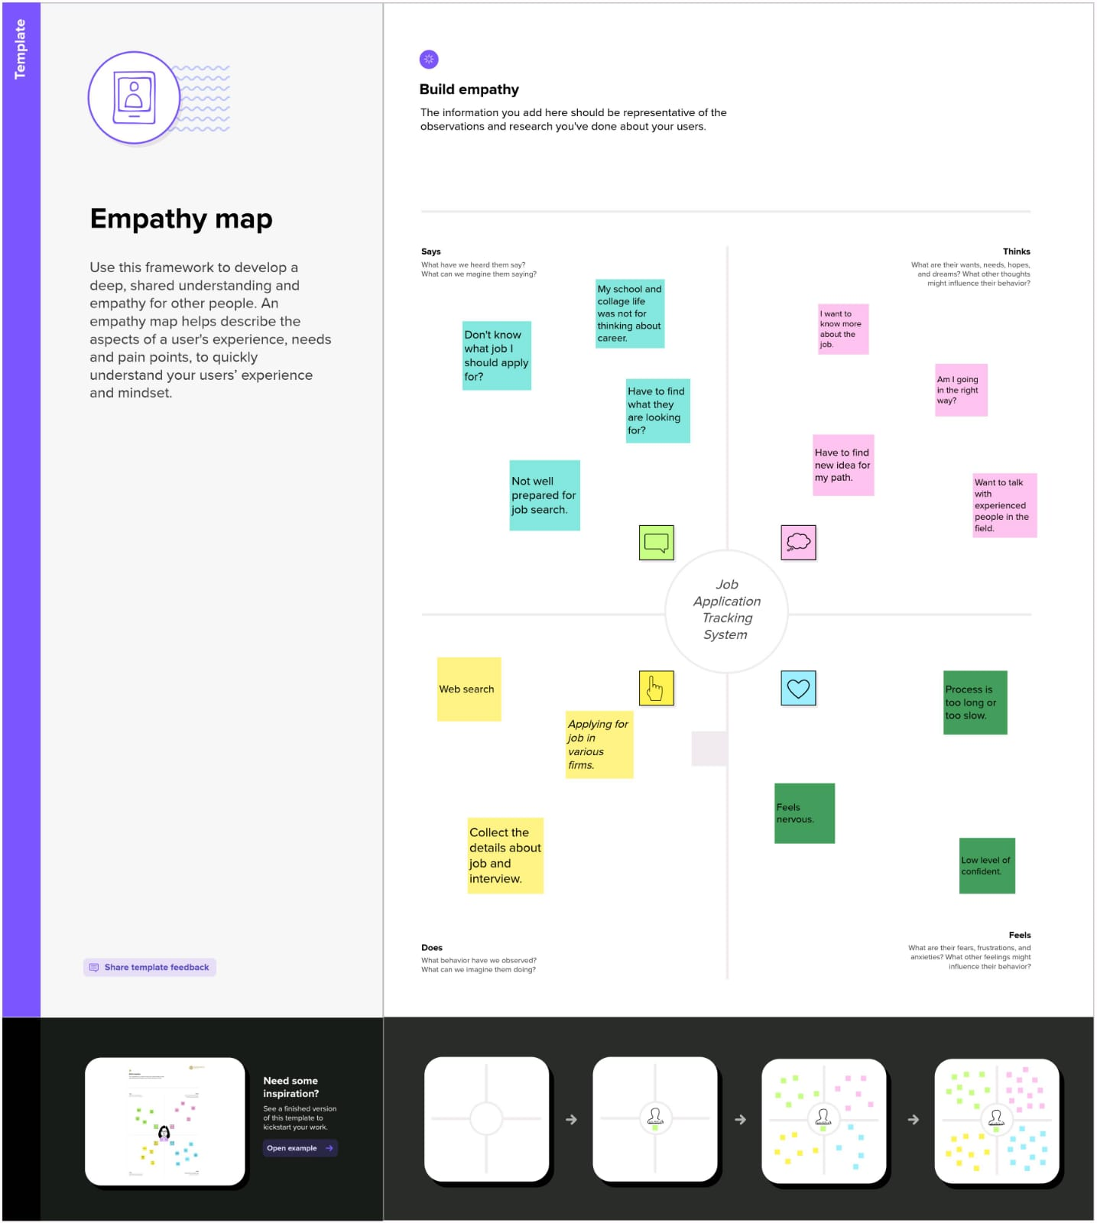

3 . RESULT

|  |  |
| --- | --- |
| Object name | Fields in the object |
| Obj1 - Recruiter | |  |  | | --- | --- | | Field label | Data type | | Recruiter | Auto number | |
| Obj 2 - Jobs | |  |  | | --- | --- | | Field label | Data type | | Jobs | Auto number | |
| Obj 3 - Candidate | |  |  | | --- | --- | | Field label | Data type | | Candidate | Auto number | |
| Obj 4 – Job applications | |  |  | | --- | --- | | Field label | Data type | | Job applications | Auto number | |
|  |  |

4 . Trailhead Profile Public URL

Team leader - <https://trailblazer.me/id/uplaniyandi>

Team member 1 - <https://trailblazer.me/id/aphysicsem>

Team member 2 - <https://trailblazer.me/id/nkumar2890>

5 . ADVANTAGES & DISADVANTAGES

Advantages :-

∙ Flexible system for both employer & agency

∙ Faster & better decisions

∙ Advanced search of jobs in various fields

∙ Entire recruitment cycle speeds up

Disadvantages :-

∙ Missing out on potential great hires and talent due to

Automatic elimination of every resume that the system

Cannot read and interrpret

∙ Missing qualified applicants due to wrong keyword selection and

And open to manipulation

6 . APPLICATIONS :-

∙ In job application tracking system the core of any applicant tracking software is a database that stores the candidate details.

∙ Depending on the application, they can posting job listings, headhunting, parsing and evaluating candidates, interviewing, and making offers throughout the hiring process.

∙ It handles the recruitment process, namely by sorting through thousands of resumes,to determine which ones are the best fit for the positions for which they were submitted.

∙ This program will process a resume application and then present that to hiring managers in an easy to navigate HR tool. No more spreadsheets !

7 . CONCLUSION :-

∙ Job application tracking system is an widely used and helps recruiter and employers to track candidates throughout the recruiting and hiring process easily and faster

∙ From this work we were able to know this field the advanced hiing process and job opportunities in various fields.

8 . FUTRUE SCOPE :-

The below enhancements will be used in tracking system,

∙ AI and Machine learning in recruitment

∙ Big data analysis in recruitment

∙ Digital revolution, remote workforce, and robotization